University of California “CapEquip” Program Guidelines

- Description. CapEquip is an internal loan program whereby UCOP extends low fixed-rate loans to campuses, medical centers, and/or laboratories (hereinafter, “Participants”) for the purpose of acquiring capital equipment. The Office of Capital Markets Finance administers the program and funds loans through use of the Regents’ Commercial Paper (CP) Program. The rate on the loans is set annually and applies to loans extended during the subsequent fiscal year.

- Policy Basis. At its November 19, 2009 meeting, the Board of Regents authorized the use of the Regents’ CP Program for the financing of capital equipment purchases. By means of interim Regents’ approval, the enabling language was later expanded on May 4, 2010 to explicitly allow permanent financing of equipment via the CP Program. The CP Program is now authorized for:

(1) the interim financing of capital projects and equipment, permanent financing of equipment, and financing of working capital for the teaching hospitals and other working capital needs and (2) standby/interim financing for gift-related projects.

- Annual Authorization. In order to participate in CapEquip, each Participant must, by March 1 of each fiscal year, submit to the Office of Capital Markets Finance an IRS Declaration (Schedule A; see sample attached) stating: (1) desired total authorization amount for the upcoming fiscal year in $1,000 increments; (2) brief description of expected purchases; and (3) expected repayment source. The Office of Capital Markets Finance will then submit a recommended aggregate authorization (delineated by Participant) to The Regents in May for approval. Maximum authorization cannot be increased during the fiscal year; however, if authorization is depleted during the fiscal year, the traditional capital leasing program remains in place and can be utilized as normal. Unused authorization lapses yearly on June 30.

- Debt Capacity. The final approved authorization per Participant serves as the maximum authorization for the fiscal year. The Participant is not obligated to utilize the full amount; however, the full amount will be counted against debt capacity until actual utilization at fiscal year-end is known. Hence, approval of the authorization amount is subject to debt financing feasibility metrics.

- Loan Characteristics. The equipment must have a useful life of at least three (3) years. In the case of smaller equipment purchases bundled together, the average useful life must equal at least three (3) years. Minimum amortization is three (3) years. Maximum amortization is seven (7) years. The minimum size for any individual loan is $100,000. Smaller equipment purchases may be bundled together to reach the minimum of $100,000. Loans will be written in even $1,000 increments.

- Reimbursements. The Office of Capital Markets Finance will fund loans at the end of each quarter, in September, December, March and June. In practical terms, this means Participants may purchase equipment anytime during the fiscal year but may only be reimbursed quarterly. If desired, Participants may accumulate expenditures across multiple quarters before requesting reimbursement. At the end of each quarter, the Office of Capital Markets Finance will accept reimbursement requests from Participants. Requests shall include: (1) purchase details (e.g., purchase orders, invoices, etc.); (2) desired amortization term (3-7 years); (3) detailed description of the equipment; (4) detailed description of soft costs (e.g., installation, etc.); and (5) repayment source. Participants will then execute a Promissory Note in an amount equal to the funding request (rounded down to the nearest $1,000 and subject to the annual authorization limit). The Promissory Note will delineate the loan terms and the debt service schedule. After receiving the signed Promissory Note, the Office of Capital Markets Finance will transfer funds to the Participant on/about the last business day of the quarter.

- Debt Service. Each loan will carry one uniform amortization schedule; pro-rating for purposes of departmental recharge is the responsibility of the Participant. The Office of Capital Markets Finance will assess interest expense from the campus semi-annually in arrears on November 15 and May 15. Principal will be amortized each May 15 with full amortization not to exceed seven (7) years. CapEquip loans may not capitalize interest under any circumstances. The cost of funds is the CapEquip rate, set annually (and subject to review) by the Office of Capital Markets Finance (see http://www.ucop.edu/finance/ucsip.html). There are no fees. There are no principal prepayment penalties.

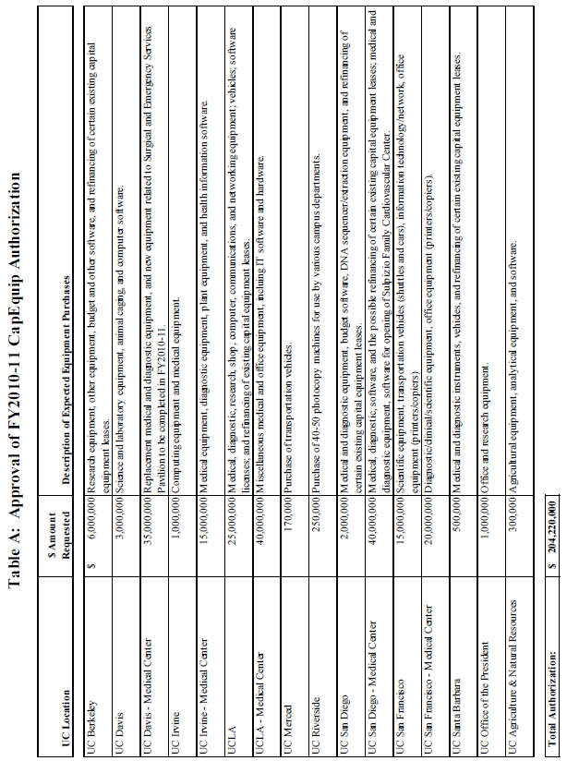
FY2010-2011 CapEquip Authorization Approved by Board of Regents on July 14, 2010:
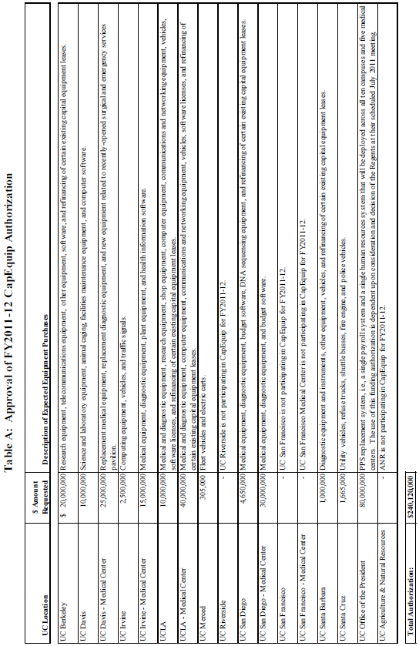
FY2011-2012 CapEquip Authorization Approved by Board of Regents on May 18, 2011:

BULLETIN NO.: BUS-43 Rev.
DATE: 8/15/98
PAGE: 91 of 107

ATTACHMENT

SAMPLE

SCHEDULE A
Declaration of Official Intent
of The Regents of the University of California
to Reimburse Certain Expenditures
from Proceeds of Indebtedness

Expected Total Costs to be
Paid From Indebtedness

Project*

UC Xxxxxxxxx Medical Center FY2010-11 CapEquip Authorization

- Total Authorization request:
$34,839,000

- Description of Expected Equipment Purchase(s):
Medical equipment, diagnostic equipment, budget software, and refinancing of certain existing capital equipment leases.

- Expected Repayment Source(s):
Clinical revenues, indirect cost recovery, and other campus funds.

____________________________________________________________
Participant Signature/Title Date

*Instructions: Provide a general functional description of each Project (e.g., "five acres of unimproved land" or "a ten-floor office building") in enough detail so that it may be distinguished from other projects.

This form may be found at: http://www.ucop.edu/ucophome/policies/bfb/bus43exh-d.pdf or http://www.ucop.edu/finance/ucsip.html (see “CapEquip Guidelines”).

