Recycling in Multifamily Dwellings:
A Model for Local Government Recycling and Waste Reduction

Overview
Recycling for residents of multifamily dwellings (MFDs) poses a challenge for many communities. (For purposes of this study, an MFD is a building with more than four residential units.) MFD residents can generate a large amount of a community’s residential waste, and they often desire curbside recycling collection. Yet, these residents are frequently left out of community curbside recycling programs because:
- Programs for individual households are not suited to MFDs.
- Private waste haulers, not local government, typically provide waste management services to MFDs.
Many MFD buildings were not designed with recycling in mind. MFDs typically have little space in individual units and in common areas for the collection and storage of recyclables.
Nationally, approximately 16 percent of all housing units are in structures with five or more units. The proportion is much higher in California—approximately 24 percent. Furthermore, some communities have an even greater proportion of their housing units in multifamily structures. Approximately 45 percent of housing units in San Francisco, 34 percent of Los Angeles units, and 29 percent of units in San Diego are in buildings with five or more units.
Despite these obstacles, communities can increase recycling rates in their MFDs by requiring that building management provide recycling opportunities, by developing programs that encourage resident and management recycling, and by providing assistance with program design and education.
In general, waste diversion rates in MFD recycling programs are lower than in those serving single-family homes. A recent study of municipal MFD recycling programs reported the average program diverted 15 percent of residents’ waste from disposal through recycling. Only 11 of the 40 communities studied achieved MFD recycling rates of more than 20 percent. (Multi-family Recycling: Costs, Diversion, and Program Characteristics, U.S. Conference of Mayors, 1999.)
While the results of this study are typical of MFD recycling rates, they do not show the possibilities. Numerous communities and individual buildings and complexes have surpassed 30 percent, 40 percent, and even 50 percent waste diversion levels. For example:
- The Central Contra Costa Solid Waste Authority achieved a 29 percent waste diversion rate in its MFDs during 1999.
- At the Richmond, a 121-unit, 23-floor condominium on the East Side of New York City, residents recycle approximately 46 percent of their discards.
- Leisure World in Laguna Hills and Blossom Hill Estates in San Jose—two California MFD complexes—report 50 percent recycling rates.
There is no single model for a successful MFD recycling program. Variations in building size, layout, resident characteristics, landscaping, and trash disposal systems require unique arrangements to suit specific sites. For example, some MFD recycling programs collect both recyclables and yard debris. Others collect only recyclables. Some require residents to deliver materials to a central location. Others provide collection from doorways or at curbs. In general, successful programs provide residents with the convenience of curbside collection while fitting into existing waste management systems.
This information on recycling programs and policies will help jurisdictions encourage recycling in their multifamily dwellings. It presents examples and highlights from existing efforts across the United States. Individual profiles feature the multifamily recycling programs in the

California communities of Central Costa Contra County, Davis, and Malibu.

Program Characteristics
Instituting an MFD recycling program requires planning and continuing follow-up. Program elements include:
- Conducting waste and site assessments.
- Identifying and enlisting participation of key players.
- Implementing an outreach and education plan.
- Determining what materials to collect.
- Designing a collection system.
- Monitoring progress and providing feedback to program participants.

Waste and Site Assessment
Waste assessments provide baseline information about what is in the waste stream at typical MFD units, and they can help identify recyclables generated at buildings with established programs. The data is helpful when identifying materials to target for collection. Assessments can also help determine the best size for recycling containers and/or provide insight into needed program refinements.
A site assessment can identify the location of trash collection areas, the volume of trash containers, and their collection frequency. It can also highlight potential areas for recycling collection and storage and note any problems with the current system (such as overflowing trash containers or odor problems). Ideally, every building or complex should have a site assessment. To assist MFD management in the assessment process, city/county recycling staff may develop and distribute a simple site assessment guide and/or form.
For example, Davis, Calif., requires the owner or management of each MFD complex to assess the site and submit a recycling plan. The city developed a simple form, “Recycling Collection Site Plan,” that managers can use to supply the required information. Managers report the number of trash and recycling containers on site and provide sketches of collection areas and their locations within the complexes.

Key Players
Participation of residents, building management, maintenance staff, and trash and/or recycling haulers is critical to a successful MFD recycling program. Including each group in the planning process can help them accept the program. Furthermore, each group may have specific knowledge that can improve a program. For example, residents may suggest placing additional recycling containers near trash bins that often get overfilled. Haulers familiar with local markets can help determine which materials to collect and how they must be sorted.

Outreach and Education
Education is an important tool to encourage participation in any waste reduction program. Recycling education messages should address both the “hows” and “whys” of recycling, be easy to understand, and be repeated often.
Educational programs are necessary to provide residents with the knowledge to recycle correctly. Some people lack the necessary knowledge and skill to recycle even though they may want to do so. However, knowing how to recycle may not be enough for some residents. Research has indicated that individuals who connect recycling with the larger issues of resource conservation and environmental protection are more motivated to participate in recycling and reuse programs.
Recycling messages should be easy to understand. California has a high percentage of residents who are non-English-speaking or who speak English as a second language. To address language barriers, communities may produce outreach materials in multiple languages or use illustrations of materials that can be recycled.
For example, El Monte, Calif., uses bilingual waste auditors to reach residents of multifamily units. The city distributes a brochure and a poster with text in both English and Spanish, side by side, to encourage residents of multifamily buildings to recycle. It has also released several bilingual local public service announcements on recycling.
Portland, Oreg., has produced outreach materials in ten different languages. Recycling officials selected English, Spanish, Vietnamese, Russian, Bosnian, Chinese, Korean, Japanese, Cambodian, and Laotian based on a survey of highly used languages in Portland.
Because MFDs have higher turnover rates than single-family homes, education efforts must be continual and more intensive. Some communities use on-site representatives to distribute information to new residents, or they ask building managers to distribute information when residents sign leases. Others distribute recycling information to MFD residents several times a year.
The City of Mountain View, Calif., uses MFD resident volunteers to spread recycling messages through its “Recycling Leader” program. Recycling Leaders distribute educational materials and serve as recycling advocates in their buildings. Three times a year, the City of El Monte mails a recycling newsletter to all residents of multifamily units.
MFD recycling station at a complex in Saint Paul, Minn.

Determining Which Materials to Collect
Waste characterization, local markets, and program convenience can influence decisions about the materials collected. Obviously, programs that target more materials have the potential to reach higher diversion levels. A waste characterization study or survey can help communities identify materials that make up a large proportion of waste disposed.
If local markets exist, communities may consider adding these materials to programs if they are not currently accepted. They can also educate residents about existing recycling opportunities. For example, a 1998 survey revealed that while 84 percent of respondents said their MFD facility produces green waste, only approximately one-third divert it from disposal. (Central Contra Costa [Calif.] Solid Waste Authority.)
The Central Contra Costa Solid Waste Authority is seeking to increase use of its MFD green waste collection program.
Allowing residents to commingle recyclables can enhance convenience and participation. Policy decisions about acceptable materials should incorporate the requirements of local processors and try to balance it with the goal of accepting as many materials as possible.

Determining a Collection System
Communities and complexes use many types of containers for collecting recyclables at MFDs.
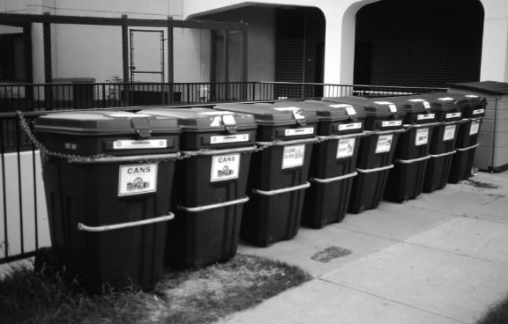
Some provide individual containers to each apartment and others use centralized containers for the entire building. Large complexes often establish multiple collection stations. Typical locations for collection stations include laundry rooms, mail rooms, trash rooms, next to outside trash dumpsters, and parking garages.
Many MFD units are too small to accommodate the 14- to 20-gallon recycling bins often used in single-family curbside recycling programs. In response to this problem, some manufacturers produce small recycling collection containers designed to fit under sinks or in other small spaces. For MFDs in Central Contra Costa Solid Waste Authority service areas, Valley Waste Management provides containers for storage and transport of recyclables from individual units.
Complex and/or building layout can affect the choice of containers to use for collecting recyclables. Cities/counties may consider allowing residents of townhouse, condominium, and garden-style apartment complexes—where each unit has curb access—to participate in their single-family curbside collection programs.
High-rise buildings present a challenge for recycling planners. Older buildings often do not have sufficient space for recycling collection containers on each floor or for storing large quantities of recyclables between collections. Some buildings have specialized recycling systems with converted trash chutes to overcome space constraints.
For example, the 187-unit high-rise Commodore Club in Key Biscayne, Fla., uses a chute for trash and recyclables. Computer controls ensure that source-separated materials drop into the proper receptacle. This system allows residents to deliver both trash and recyclables to the same place.
The Syracuse Housing Authority in Syracuse, N.Y., has brought the convenience of curbside service to some of its public housing residents. Where space allows, residents receive door-to-door pickup of both trash and recyclables. In some high-rises, residents receive door-to-door pickup of recyclables but must bring trash to a chute, which empties into a basement compactor.
Collection containers do not have to be elaborate but they must be well marked. Dumpsters, carts, and cardboard boxes work well. Color-coding containers can help residents differentiate trash containers from those for recyclables. For example, Central Contra Costa uses color-coded carts for collection of recyclables at many of its MFD complexes. The Solid Waste Authority’s collection contractors provide burgundy carts for recyclables, green carts for yard debris, and blue carts for trash.
Collection of recyclables can be performed by MFD complex trash haulers, by a separate recycling hauler, or by complex staff. Collection of recyclables should be frequent enough to prevent containers from overflowing or developing odors.

Monitoring and Feedback
Monitoring program success and providing feedback to residents helps them understand that their efforts do indeed make a difference. For example, in Saint Paul, Minnesota, the city requires haulers to report monthly pickup information for each account served. The city’s contracted recycling company, Saint Paul Neighborhood Energy Consortium, distributes posters that building managers can use to graph these data and display recycling achievements. Communicating successes and failures to building management in a timely manner can alert them to potential difficulties. This will help them solve problems before low participation or contamination jeopardize program viability.
In East Orange, N. J., MFD recycling collection staff members note any decreases in materials recovered and increases in contamination at buildings on an ongoing basis. When collection staff members report problems, the city works with building management to rectify the problem. Communication with MFD residents and managers can help community planners improve recycling programs and outreach efforts.

Costs, Economics, and Benefits
In most communities, MFD solid waste service costs are based on container size and collection frequency. Many haulers (both public and private) collect recyclables and/or yard debris at a lower cost than collection and disposal of an equal volume of trash. Other haulers provide recycling and yard debris collection to their trash customers at no additional cost.
For example, San Jose, Calif., charges MFDs for trash service and provides recycling and yard debris collection at no additional cost. One area MFD complex, Blossom Hill Estates, avoided almost $60,000 in trash disposal fees in 1997 through recycling and composting. In many cases, the community or hauler provides collection carts and bins. Apartment management can often reduce their total solid waste management costs if residents recycle enough to reduce needed trash container size or collection frequency.
The Commodore Club in Key Biscayne, Fla., reduced trash collection and disposal costs after implementing its recycling program. Building management saves approximately $1,600 per year on waste management costs.
Because of the communal nature of most trash collection and billing systems at MFD complexes, it is difficult to pass savings directly on to those residents reducing disposal. The complex management may pass savings on to all residents equally through reductions in rent or fees, or through foregone rent increases.
Some complexes have developed systems of economic penalties to encourage recycling by individual tenants. For example, if the management at Blossom Hills Estates in San Jose, Calif., finds a lot of recyclables in trash from a particular household and the household does not begin to comply with the recycling program, the complex can fine the residents $30.
Community costs for MFD recycling programs vary according to whether the community provides services directly or through a contract or franchise. Typical costs for MFD recycling services can include those for equipment, labor, transportation, contracts, education, advertising, and administration. Tip fees are also a cost. Some communities require contracted and/or franchised haulers to provide equipment and conduct outreach efforts.
Revenues from the sale of recyclables and avoided disposal costs often defray program costs. For example, East Orange, N. J., provides trash and recycling services to its 6,236 MFD households for less than it would pay for trash collection alone. Reduced tip fees offset increased costs of the city’s recycling collection program. The city pays no tip fee for recyclables, while trash disposal tip fees average nearly $75 per ton.
Communities using contractors can reap benefits from these savings by negotiating reduced contract costs. They can use a system where their contractors pay less per ton for recycling than for trash.
Communities may fund MFD recycling efforts through trash or recycling service fees, the tax base, and/or franchise fees. Some communities also receive revenue from the sale of recyclables.

Local Government Challenges and Opportunities
Below are some of the ways communities can establish programs and policies to assist recycling efforts in multifamily dwellings:
Pass a local ordinance requiring residents of MFDs to recycle. In 1995 the City of Malibu established a resolution requiring MFD residents to source-separate their discards and participate in a recycling program. This ordinance states:
“All persons residing in multifamily dwellings and commercial premises within the City shall comply with the following:
A. The recyclable materials [newspaper; magazines; cardboard; phone books; high grade paper; glossy paper, envelopes; junk mail; glass food and beverage containers; aluminum and tin cans, foil, and pie tins; bi-metal cans; #1, #2, and #3 plastic bottles; and metal coat hangers] identified in Section 4 (A) of this Resolution shall be segregated from other refuse and stored in the recyclable containers provided for that purpose by the collector...”
Pass a local ordinance requiring management of MFD complexes to offer recycling services to their tenants. One of the only ways to identify individual residents of MFD complexes who do not recycle is to sort through trash for recyclables and find an item that reveals the identity of the disposer. Communities may find it easier to enforce an ordinance mandating recycling at MFDs than to enforce one aimed at individual residents.
A Portland, Oreg., ordinance requires MFD complexes to establish recycling programs that collect scrap paper, newspaper, and three other materials. Studies by the Portland Bureau of Environmental Services revealed the proportion of complexes with no recycling program dropped from 10 percent in 1995 to 2 percent in 1996 as a result of the ordinance.
Require hauling companies to offer recycling services to MFDs. Communities can require hauling companies to provide MFD recycling services by ordinance or by contracts and franchise agreements. The Tehama County Sanitary Landfill Agency’s franchise agreement with GreenWaste requires GreenWaste to provide its MFD trash customers with recycling and yard debris collection at no additional cost. The company must provide carts and bins for trash and recyclables and must accept certain materials for recycling.
Pass a local ordinance that includes requirements in building codes that new development and renovations of MFD properties include provisions for recycling. Apartment residents and managers often have difficulty implementing recycling programs because of lack of space. Older buildings and facilities were typically designed assuming discarded materials would be handled as a single (trash) stream. Older facilities may not have sufficient space on loading docks and in storage areas for multiple receptacles.
Modern recycling and waste reduction programs can require sorting of materials into multiple fractions. These problems will gradually disappear after revision of building codes requiring provision for recycling in new construction and during renovations.
The California cities of Agoura Hills, Fresno, and Santa Monica have enacted such ordinances. Chapter 12, article 3, section 12-306 of Fresno’s Municipal Code reads in part:
“The following property development standards and special standards of practice and regulations shall apply to all land, buildings, uses and structures in all districts...
50. Accessible on-site recycling facilities are required to be included in any development project for which a special permit is required, and in any residential development project where solid waste from five or more dwelling units is collected at a centralized location. The following requirements apply to on-site recycling facilities:
a. Areas used for collecting and loading solid waste shall include adequate, accessible, and convenient areas for collecting and loading recyclable materials. Recycling areas shall be located so that they are at least as convenient as the locations for solid waste for the depositing, collecting, and loading of recyclable materials placed therein. Wherever feasible, areas for collecting and loading recyclable materials shall be adjacent to solid waste collection areas...
i. Signage is required to clearly identify all recycling and solid waste collection and loading areas, and the materials accepted therein. This signage shall be placed at all points of direct access to the recycling areas and on, or adjacent to, the recyclable materials containers.”
Institute incentives for MFD residents, building management, and/or waste haulers that provide recycling services. Because waste disposal companies usually bill the management directly, MFD residents may not see reduced costs associated with increased waste diversion.
One way to reward residents of MFDs with successful programs is to provide recycling credits on bills for other municipal services, such as municipal water or electric service. While such a system could not reward tenants based on their individual recycling efforts, tenants would receive a savings related directly to the building’s recycling progress. The potential for further rate reductions may increase peer pressure on non-recyclers to participate.
Some communities provide incentives to building managers to establish, improve, or promote recycling. For example, Seattle’s “Friends of Recycling” volunteer program trains individuals who then champion recycling within their buildings. The volunteer can be either a resident manager or a tenant. Seattle issues an annual $100 rebate on trash bills to the management of buildings with Friends of Recycling volunteers.
In communities with franchised or contracted haulers, incentives can become a way to increase hauler commitment to recycling. San Jose pays its recycling contractors an incentive fee for each ton of recyclables they market to end users. Another community offers lower franchise fees to haulers that meet threshold recycling goals.
Provide recycling services directly to MFDs. Communities may choose to provide recycling services directly to MFD tenants if contractor prices are too high.
For example, East Orange, New Jersey, hired one contractor to provide alternating week recycling services to single-family residences and small MFDs. The city hired another contractor to collect trash from all residences, both single- and multifamily. City employees provide separate weekly recycling collection service to complexes with 50 or more units. By providing the services directly, the city can more closely monitor recycling progress among its MFDs. They can effectively target educational resources where they are most needed and collect more frequently.
Provide educational materials (posters, signs, how-to brochures) or hands-on assistance to MFD residents and building management.
Recycling outreach and education are critical to program success. Most MFD management does not have the time or expertise to develop their own recycling outreach materials or design the most efficient system for collecting and storing recyclables. Communities that distribute outreach materials regularly will supply residents and management with timely, correct information.
By providing on-site assistance, communities can share expertise gained by working with other MFD programs. For example, a community representative may be able to suggest alternate containers for use in buildings with insufficient space for standard recycling containers.
Develop a program to identify new residents. To avoid potential contamination problems, recycling coordinators should identify new residents quickly and provide them with recycling guidelines. Central Contra Costa designed a phone book insert about its recycling program. New residents receive the insert with their phone book when phone service is set up. The City of Davis also identifies new residents by monitoring phone service accounts. The city sends its “Garbage Guide” directly to every new phone service customer in the city.
Encourage landlords to require recycling in leases. In San Jose, the trash and recycling contractor’s staff developed model lease agreements for MFDs. The agreements covered recycling policies and encouraged MFD management to adopt them.
Deny recycling and/or trash service if complexes consistently set out contaminated materials. Contamination of recyclables can lower the value of materials or make them unusable. The few who recycle incorrectly—contaminating recycling bins with the wrong items or throwing away recyclables—can greatly influence others. This is especially true in buildings with common recycling areas. Penalizing complexes that do not recycle correctly gives management and maintenance staff an incentive to monitor and reduce contamination.
A local recycling ordinance in East Orange, N. J., allows the city to fine apartment management and/or discontinue both trash and recycling services for failure to comply with the city’s requirements. If city collection service were discontinued, management would have to pay a private hauler. This is a strong incentive to recycle, since city property taxes include collection costs.

Tips for Replication
- Involve residents and complex management in program planning and implementation.
- Provide waste reduction education and information to new residents when they first move into units.
- Provide clear, simple explanatory materials.
- Use multiple means of getting the message out—including tenant meetings, newsletters, lease clauses, posters celebrating achievements, and direct mailings.
- Re-educate whenever programs change. For example, hand out flyers whenever new materials are added.
- Use volunteers in the building to communicate with other residents about program difficulties and successes.
- Make resident participation simple and convenient and reward it.
- Require that residents recycle through their lease agreements.
- Provide ongoing support to complex management, including technical assistance and outreach materials.
- Ensure management support and long-term commitment.
- Pay attention to the needs of your collection staff; they are an important element in a successful recycling system. Be open to letting workers create systems that work for them, and listen to their concerns.
- Provide feedback. Mail residents letters and talk to them.
- Mandate waste reduction program availability and participation.
- Require haulers to provide recycling service to MFDs.
- Create a mechanism for encouraging owners or managers of buildings to comply with recycling requirements.
- Consider using municipal employees to implement the program because of the opportunity for increased oversight.
- Show owners that they can realize big savings through recycling.
- Educate building owners. Owners can only use services they know about.
- Produce educational materials using simple graphics.
- Produce educational materials in multiple languages if some of the MFD residents do not speak English.
- Be persistent. Maintaining high diversion levels at multifamily homes requires ongoing efforts from recycling coordinators and building managers.

Case Study: Central Contra Costa Solid Waste Authority

Overview
The Central Contra Costa Solid Waste Authority (CCCSWA) is a joint powers authority that oversees waste management services in most of Central Contra Costa County. The authority serves the Town of Danville, the City of Lafayette, the Town of Moraga, the City of Orinda, the City of Walnut Creek, and the central portions of unincorporated Contra Costa County.
An estimated 209,300 residents live within the CCCSWA service area. Authority staff manages trash, recycling, and yard debris franchise agreements. Staff members plan, promote, and manage a variety of other diversion programs to help member agencies meet the goals of the California Integrated Waste Management Act of 1989 (AB 939, Sher, Chapter 1095, Statutes of 1989 as amended) and provide public information and education.
In 1999 multifamily dwelling residents in the CCCSWA service area reduced their trash disposal by 29 percent through recycling and composting of yard debris. The program targets many materials, including yard debris, for diversion. It provides recycling and yard debris services for no additional cost and sets variable trash rates to encourage reduction in disposal.

Program Description
Franchised companies provide all solid waste collection services within the authority service area. CCCSWA granted Pleasant Hill Bayshore Disposal (PHBD) an exclusive franchise for collection of trash within the service area, including trash from MFDs. The authority contracts with Valley Waste Management (VWM) to provide residential recycling and yard debris collection services. All buildings with five or more units receive services through the MFD program.

Figure 1—CCCSWA Demographic Data
Jurisdiction | Population | Total Households | MFD Households Served
Danville | 40,900 | 14,170 | 534
Lafayette | 24,400 | 9,170 | 1,127
Moraga | 16,899 | 5,660 | 605
Orinda | 17,500 | 6,500 | 230
Walnut Creek | 64,400 | 29,360 | 11,055
Unincorporated areas | 45,300 | 16,778 | NA
Total | 209,300 | 81,638 | NA
NA = Not available
Source: Association of Bay Area Governments, State of California Department of Finance, and Central Contra Costa Waste Authority, 2000.

The authority’s franchise agreements with PHBD and VWM set compensation rates for the companies. The agreement with PHBD requires the company to provide trash containers for all its customers. The agreement with VWM requires the hauler to provide each MFD complex with labeled containers for collection of all recyclables and yard debris produced. It specifies the required materials to be accepted for recycling, and it requires VWM to provide individual apartment recycling bins upon request by individual tenants.
Figure 2—CCCSWA Multifamily
Dwelling Waste Reduction Results (1999)
 | Tonnage
Recycling | 3,555
Mixed paper | 2,282
Newspaper | 852
Cardboard | 74
Aluminum | 11
Glass | 263
Tin | 28
# 1 resin plastics | 17
# 2 resin plastics | 25
# 3–7 resin plastics | 2
Asceptic packaging | 1
Composting | 2,421
Yard Debris | 2,421
Total Waste Reduction | 5,976
Disposal | 14,362
Trash collection | 14,258
Residuals | 104
Total Generation | 20,338
% Reduced | 29 %
Source: Central Contra Costa Solid Waste Authority, 1999
Trash, recycling, and yard debris collection services vary for each housing development. MFDs can choose from individual trash carts, communal carts or bins, or compactors. Many complexes use wheeled carts for recycling. They use one each for commingled paper, commingled containers, and yard debris. Some smaller complexes use a single split cart for recyclables. Large complexes often use split dumpsters for collection of recyclables.
Acceptable paper items include the following:
- Newspaper.
- Corrugated cardboard.
- Office paper.
- Colored paper, junk mail, magazines and catalogs, boxboard, paper egg cartons, paper bags.
- Milk and juice boxes and cartons.
- Telephone directories.
- Glass bottles and jars.
- Aluminum cans and foil.
- Tin, bi-metal, and steel cans.
- Narrow- and wide-necked plastic containers, including resin #1–5 and #7.
CCCSWA provides assistance to building owners and managers wishing to establish or improve recycling in their complexes. Staff members provide telephone and on-site assistance upon request. They distribute information with trash bills, which are sent to complex management. The authority provides management with educational flyers and posters and speaks about waste reduction, recycling, and composting at homeowners association meetings.

Costs, Economics, and Benefits
Trash rates in the authority service area vary by jurisdiction, volume of the trash container, and collection frequency. The franchised collection companies bill MFD complex management for services provided. Trash rates include recycling and yard debris collection service at no extra cost.
MFD complexes—such as townhouses—are eligible for a discounted trash rate. This discount applies where each unit has curb access and residents of each unit use an individual trash cart. The discount also goes to complexes that use a gardening service to remove yard debris.
MFD solid waste service rates range from $10 a month for weekly collection of one 32-gallon trash cart in Walnut Creek to $2,833 per month in Lafayette for collection of six cubic yards of trash six times a week. MFD complex management can reduce their total solid waste management costs if residents recycle enough to reduce needed trash container size or collection frequency.
The authority pays PHBD a flat fee for provision of trash collection and disposal services. This compensation agreement provides the trash company a financial incentive to support waste reduction and recycling. Since CCCSWA pays the company a flat monthly fee, the company can potentially save collection, transportation, and disposal costs for materials recycled without losing compensation from the authority. PHBD disposes of collected trash at the Keller Canyon Landfill in Martinez, Calif., at a cost of $45.28 per ton.
The authority pays VWM a flat fee for recycling and yard debris services. VWM retains the first $1 million in revenue from material sales as part of its compensation. The franchise agreement allows VWM to keep the next $2.5 million of revenue earned above the floor amount. CCCSWA and VWM split any additional revenue equally. This financial arrangement provides VWM with a financial incentive to increase material sales revenue. VWM delivers yard debris and recyclables for processing to a regional transfer station in San Leandro, Calif..
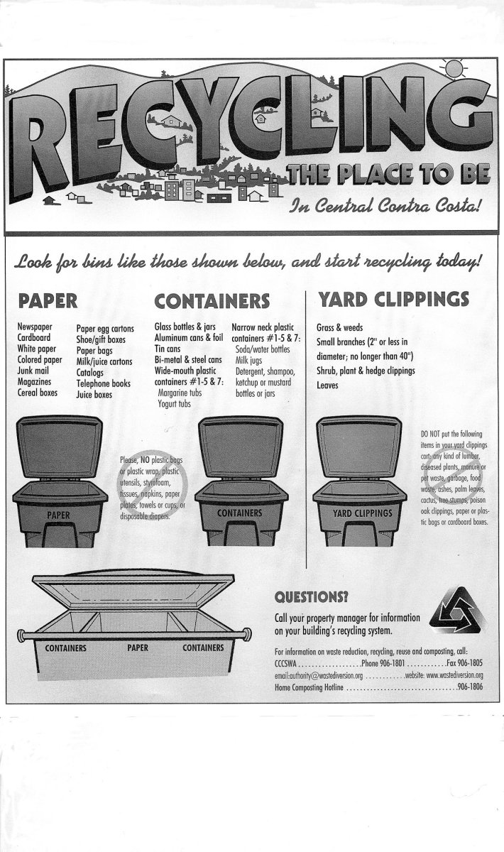
CCCSWA sets customer rates for solid waste services within its service area. The authority generates its operating funds through collection of trash fees. CCCSWA does not separate fees paid to its franchised companies by single-family versus multifamily programs. The authority pays PHBD more than $14 million annually for trash services and VWM nearly $9 million for its services.

Challenges and Opportunities in Implementation
The Central Contra Costa Solid Waste Authority is seeking to increase use of its MFD green waste collection program. CCCSWA directed VWM to contact each survey respondent that reported generating green waste to offer the complex the service at no additional charge.
Central Contra Costa Solid Waste Authority MFD recycling poster
In order to get recycling information to new residents, the CCCSWA designed a phone book insert describing its recycling programs. New residents automatically receive the insert with their new phone directories.
According to the district manager for VWM, more contamination of recyclables occurs at MFDs than at single-family homes. VWM addresses specific contamination issues on an account-by-account basis. VWM asks building management to initiate a resident education program at buildings with contamination problems. VWM monitors these accounts. If after repeated efforts the problem is not solved, VWM may refuse to collect the containers. In one MFD complex, the manager requested that VWM remove recycling containers because of ongoing contamination problems.

Case Study: City of Davis

Overview
Davis has a long history of successful recycling. Community recycling began in 1970 when a group of citizens began a newspaper drop-off recycling program. A local company, Davis Waste Removal (DWR), began curbside collection of newspapers in 1974.
Since the 1970s, Davis recycling efforts have grown to include curbside collection of the following material from single- and multifamily residences and businesses:
- Mixed paper.
- Glass.
- Aluminum cans, steel and tin cans (including empty aerosol cans).
- All resin #1 and #2 plastic containers.
- Corrugated cardboard.
- Yard debris.
The City of Davis and DWR have won numerous awards for their recycling programs. Citations include a 1992 City and State Environmental Achievement Recycling Award and a 1991 Merit Award from the California Department of Conservation’s Division of Recycling.
Davis first reached 50 percent waste diversion in 1996. The city is focusing on reducing disposal further through more recycling and waste prevention. In its reports, DWR does not separate tonnages of materials recycled, composted, and disposed from commercial and MFD properties. Data to calculate the city’s MFD recycling rate are not available.
Approximately half of the people in Davis live in apartments and condominium complexes. In 1989, the city recognized the need to include these residents in recycling programs. Davis passed an ordinance to ensure that MFD owners and managers provide their residents with recycling services and educational materials. The city’s apartment recycling program is one element of its “4R” program. The 4R program encourages city residents and businesses to reduce, reuse, recycle, and buy recycled-content products in order to reduce trash disposal.

Program Characteristics
The city contracts with Davis Waste Removal, Inc. to collect trash, recyclables, and yard debris within the city. DWR also operates a recycling drop-off and buyback center. The city bills MFD owners and/or management for sanitation services. Davis residents can also drop off recyclables at a drop-off center operated by Yolo County at the Yolo County Central Landfill. In addition, three State-certified, privately owned redemption centers are located in Davis. These centers redeem beverage containers with California Redemption Value.
DWR provides communal recycling service to residents of buildings and complexes with 10 or more units. Complexes use green 90-gallon wheeled carts for collection of recyclables. Most complexes use three carts—one for mixed paper, one for metal cans and glass, and one for plastics. DWR asks residents to flatten corrugated cardboard and place it next to the carts for collection. Collection schedules and frequency vary from complex to complex. Davis Waste Removal processes and markets collected recyclables at its own processing facility.
DWR collects yard debris weekly. Residents place brush, leaves, prunings, and weeds in loose piles near the curb. They must place grass clippings in paper or plastic bags. DWR delivers some collected yard debris to a local composting company and some to the county landfill for use as alternate daily cover.
In 1989 Davis passed an ordinance dealing with recycling at multifamily residences. The ordinance requires apartment complex owners and managers to set aside space for recycling. They must also submit a recycling collection site plan to the city public works department and inform new tenants about the city recycling program and the building’s collection sites. The ordinance requires “[t]o the extent possible, the [site] plans must comply with the goal of siting three (3) recycling carts within, or next to, each trash enclosure.”
Davis requires apartment complexes to distribute information about the city’s 4R program to residents of MFDs. The city provides complex owners and management with educational materials for distribution. In addition, the city targets those moving into the city for 4R program outreach. The city identifies new residents through new telephone service accounts and sends them its “Garbage Guide.”

Costs, Economics, and Benefits
Davis bills MFD solid waste service accounts based on trash container volume and frequency of collection. MFD complexes can choose to use 90-gallon carts or dumpsters for trash collection. The fees include recycling and yard debris collection and range from $36.48 per month for weekly collection of one 90-gallon trash cart to $1,812.49 per month for collection of a 6-cubic-yard dumpster six times per week.
The City of Davis pays DWR a flat rate for collection of trash, recyclables, and yard debris. The city reimburses DWR for trash tip fees and allows the company to retain revenue from the sale of recyclables.
Davis maintains fees paid by solid waste customers in an enterprise fund. The city uses the fund for:
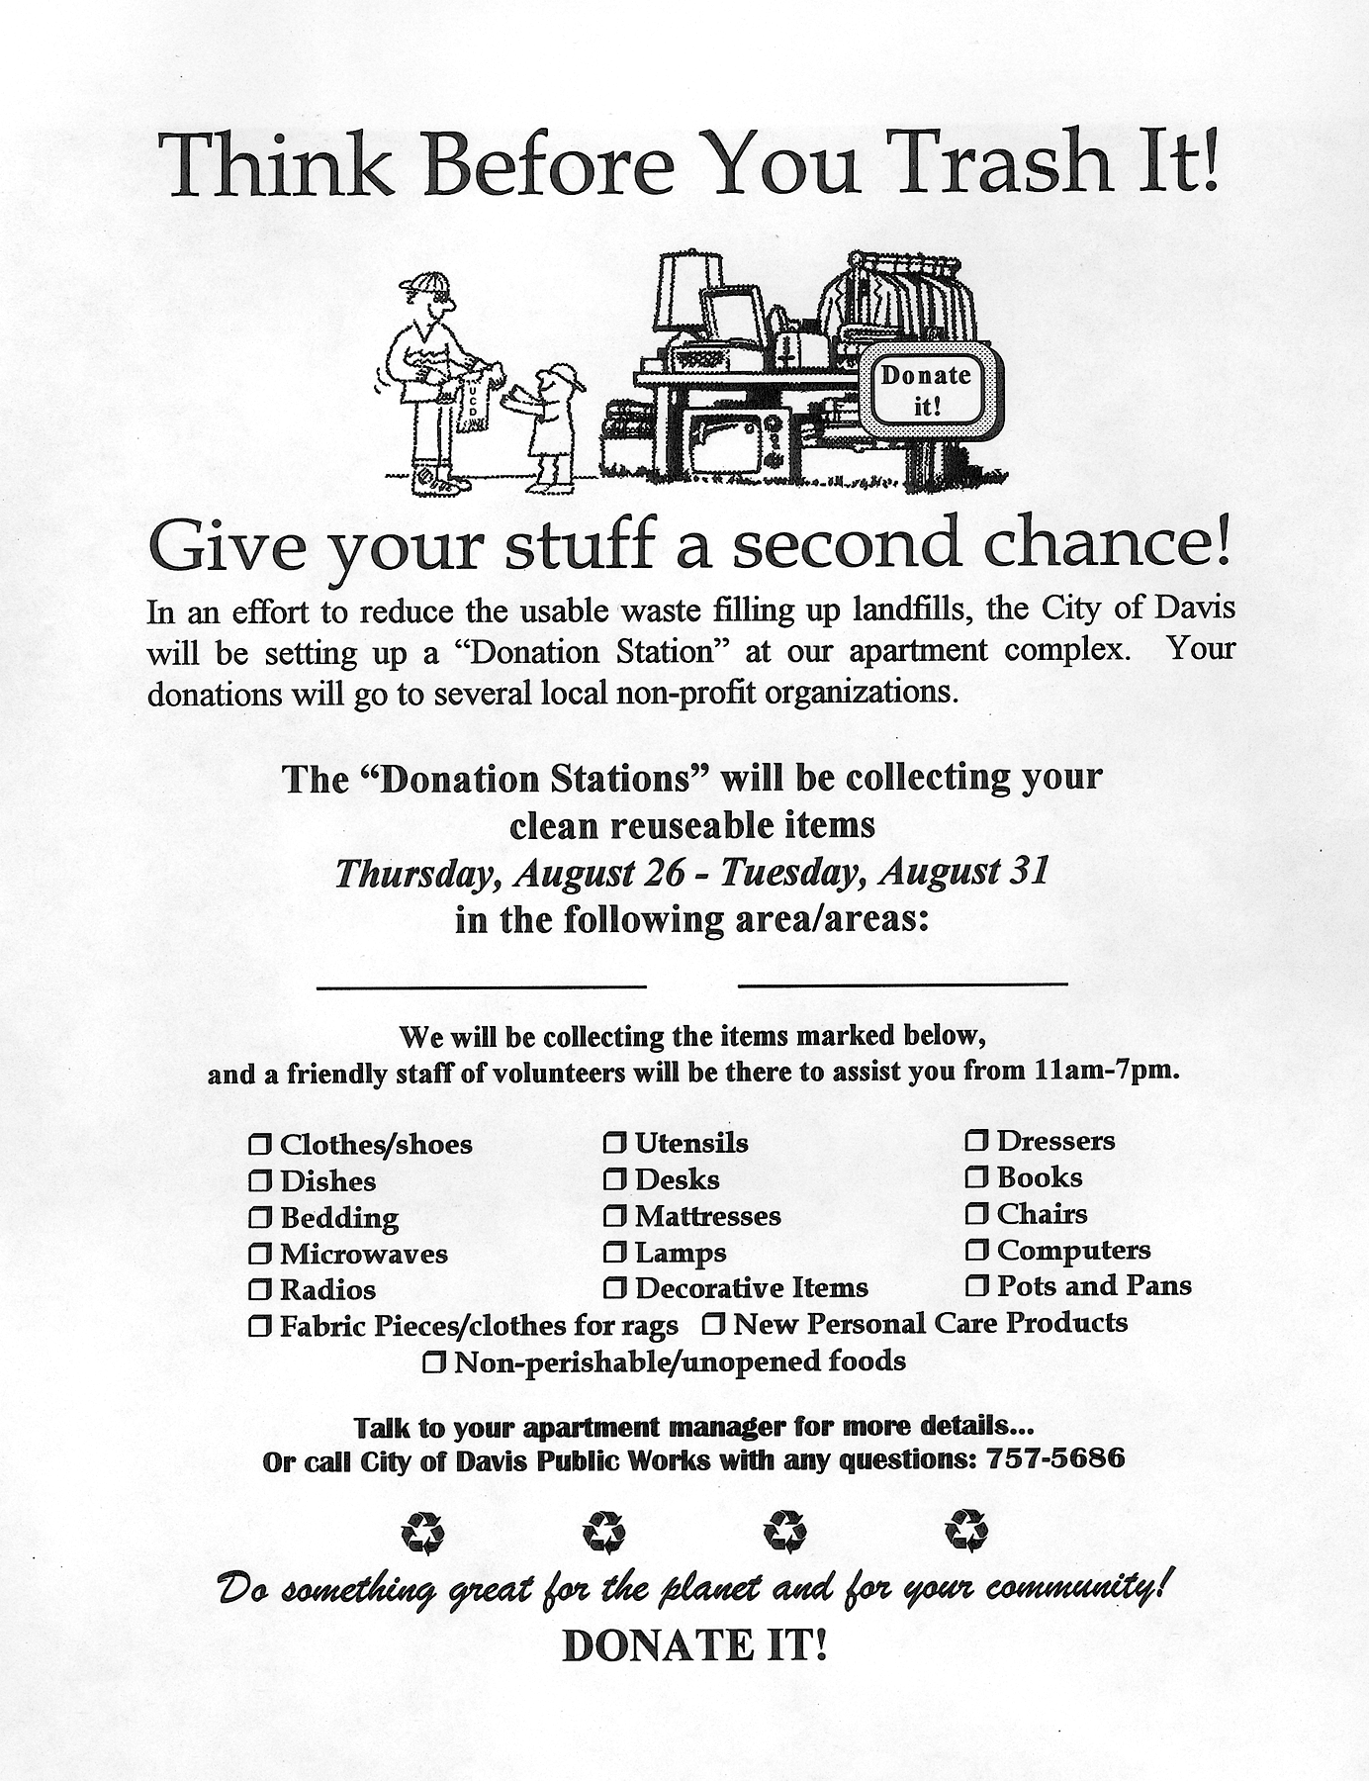
- Contract payments to DWR.
- Disposal tip fees.
- Contract oversight.
- Solid waste program planning.
- Reporting and administration.
- Billing.
- Special waste reduction programs (such as the Moveout Waste Reduction Program).
- Outreach efforts.

Challenges and Opportunities in Implementation
While Davis planned its MFD recycling program, many complex owners reported to the city that lack of space would be an obstacle to implementing the new program. The city worked closely with MFD management while developing the ordinances.
Flyer for the Davis Moveout Waste Reduction Program
City staff visited every complex to help management site and plan recycling areas. The city included an exemption in its ordinance for complexes that could not site three recycling carts at each trash enclosure without eliminating or reducing
“[e]xisting trees or other significant landscaping features . . . and space currently designated for automobile or bicycle parking.”
Because the city included MFD management in the planning process and assisted in program startup, all city MFD complexes implemented recycling programs.
Davis experiences high turnover in its MFDs at the end of August each year. The movers generate tons of material, much of it potentially reusable or recyclable. The city traditionally disposed this material.
In August 1999, Davis piloted its “Moveout Waste Reduction Program” to increase reuse and recycling of these materials. The program targeted 15 apartment complexes where tenants were vacating more than 600 units.
Program staff members asked movers to separate clothing, shoes, small household items, books, furniture, appliances, scrap metal, and corrugated cardboard from trash. Local charities and community organizations accepted reusable items. Employees collected broken furniture, scrap metal, wood, and cardboard for recycling. As a result of the program, participating complexes reduced trash disposal by eight tons over the previous year.

Case Study: City of Malibu

Overview
Malibu is a new city east of Los Angeles. It is sandwiched between the Pacific Ocean and the Santa Monica Mountains east of Los Angeles. The city’s 13,000 residents live on a strip of land 27 miles long, ranging from one to eight miles wide. The city was incorporated in 1991.
The city has approximately 1,000 MFD units. Most complexes consist of narrow low-rise buildings located on hillsides. A few complexes are townhouse-style, where each unit has a garage and curb access. Approximately 60 percent of MFD units are individually owned condominiums.
Prior to the city establishing mandatory recycling ordinances in 1995, very few Malibu residents recycled. The city achieved an 18 percent waste diversion rate in 1995, even though the ordinances were only in effect for a few months. The diversion rate increased to 31 percent in 1996. (The city does not track tonnages of single-, multifamily, and commercial materials separately.) The city’s solid waste consultant estimates that nearly 100 percent of households participate in the recycling program.
Financial incentives also support MFD waste reduction. The two private haulers operating within the city charge variable rates for trash based on volume.

Program Characteristics
Private companies offer all solid waste collection services in Malibu. The city requires the companies to be permitted. The permits costs $250 per year. Two private companies, Los Virgenes Disposal and GI Rubbish, are permitted to provide MFD solid waste services in Malibu. The companies compete in an open market for MFD customers.
City ordinances require haulers to provide recycling and yard debris collection services to their MFD trash customers. They also require MFD residents to source-separate designated recyclables and yard debris from trash. The city believed that by requiring all residents to participate in the recycling and yard debris programs, haulers would achieve economies of scale that would make their purchases of recycling equipment worthwhile.
The ordinances specify the materials haulers must accept for recycling. Haulers must provide sufficient container capacity for all generated recyclables, and they must deliver recyclables to a processing facility. The ordinance requires waste audits upon request of the city as well as reports on the tonnage of materials collected.
The MFD recycling program requirements became effective June 26, 1995; the yard debris requirements, on September 30 of that year. The city reserves the right to revoke the permit of a company failing to comply with the requirements of the ordinances (but had not done so as of March 2000).
Materials designated as recyclable by Malibu’s ordinance include the following:
- Newspapers.
- Magazines.
- Cardboard.
- Telephone directories.
- High-grade paper, glossy paper, envelopes, junk mail.
- Glass food and beverage containers.
- Aluminum and tin cans.
- Foil and pie plates.
- Bi-metal cans.
- Resin #1 and #2 plastic bottles and #4 plastic shrink wrap and bags.
- Metal coat hangers.
Residents commingle all recyclables in a single container.
The type of solid waste services haulers provide to MFD residents varies with the type of building. Residents of townhouse-style apartments, where each unit has a garage and curb access, receive the same trash and recycling services offered to residents of single-family detached homes. They pay the hauler directly for the services. Haulers provide each household with a 64-gallon recycling cart, a 95-gallon yard debris cart, and a choice of trash carts. Residents of other MFDs use variously sized communal trash roll-offs, 3-cubic yard roll-offs for commingled recyclables, and 95-gallon yard debris carts.
Both the city and trash haulers participate in recycling education efforts. The city has a Web site at www.ci.malibu.ca.us/recycle.htm that includes a list of materials accepted for recycling, reuse options for items not accepted, and composting information. The public can read text of the city council resolutions establishing mandatory recycling and yard debris programs.
City staff members also perform recycling outreach at schools and community events. The city’s permitted hauling companies have promoted recycling through distribution of informational fliers, inserting leaflets in trash bills, and providing materials for homeowners’ associations and MFD complex management to distribute to individual households.
The Malibu Department of Public Works is responsible for overseeing solid waste planning, reporting, hauler oversight, and public education. The Department hires a consultant, Solid Waste Solutions, to perform these tasks.

Costs, Economics, and Benefits
Malibu does not regulate fees haulers may charge for provision of trash and recycling services to MFDs. The city limits the cost of yard debris collection to no more than $5 per month per cart. Residents in townhouse-style apartments can choose among six trash service levels.
The hauler, GI Rubbish, charges various fees for its services. They range from $18.10 per month for weekly collection of one 32-gallon trash container to $41.45 per month for two 95-gallon trash containers. These rates include collection of one 95-gallon yard debris container and one 64-gallon recycling container.
Los Virgenes charges similar rates and offers the same service level options. At other MFDs, complex management choose trash dumpster size and collection frequency. Fees the haulers charge for these services are proprietary and therefore not available, but they increase according to container volume and collection frequency.
The city generates revenue for solid waste programs through a city surcharge on trash. As of March 2000, the surcharge was set at 60 cents per month for each household receiving trash can service and 50 cents per cubic yard for other trash. The surcharge generates approximately $100,000 in revenues per year. The city deposits the funds in a restricted fund for solid waste programs. The funds support consulting fees and other waste diversion programs such as household hazardous waste collection and rubberized asphalt.

Challenges and Opportunities in Implementation
When Malibu’s mandatory recycling ordinance was first established, the city received complaints from some residents who did not want to participate. The city sent these residents copies of the new ordinances and letters explaining why the ordinances were necessary. In general, residents have embraced the new programs and nearly all participate in them.
Malibu experienced some scavenging of recyclables, an activity prohibited by the municipal code. The problem has decreased along with commodity prices. If individuals report scavenging of recyclables, the city sends police officers to the site. Although the city has the authority to arrest and/or fine scavengers, the police have never prosecuted anyone for doing so.

For More Information

CIWMB Publications
Many CIWMB publications are available on the Board’s Web site at: www.ca.gov/Publications/.
To order hard copy publications, call 1-800-CA-Waste (California only) or (916) 341-6306 (outside California), or write:
California Integrated Waste Management Board
Public Affairs Office,
Publications Clearinghouse (MS-6)
1001 I Street
P.O. Box 4025 (mailing address)
Sacramento, CA 95812-4025

Other Publications
Complex Recycling Issues: Strategies for Record-Setting Waste Reduction in Multi-Family Dwellings. Washington, D.C.: U.S. Environmental Protection Agency, Office of Solid Waste and Emergency Response 1999. 1-800-424-9346, www.epa.gov/epaoswer/non-hw/reduce/
f99022.pdf, EPA530-F-99-022.

Multifamily Recycling: A Golden Opportunity for Solid Waste Reduction. Washington, D.C.: U.S. Environmental Protection Agency, 1999. 1-800 424-9346, www.epa.gov/epaoswer/non-hw/recycle/multi.txt, EPA 530-F-99-10.
Success with Multifamily Recycling: A Handbook for Owners and Managers. Portland, Oreg.: Metro Solid Waste Department, 1992. (503) 797-1700.
Strength in Numbers: A Handbook for Owners and Managers. Mendham, N.J : Association of New Jersey Environmental Commissions, 1987. www.anjec.org/. Video of same title, 1988, available for lending, (973) 539-7547.
Guide for Preparing Solid Waste Reduction and Recycling Plans for Multifamily Residential Units. Providence, R.I.: Ocean State Cleanup And Recycling (OSCAR), Rhode Island Department of Environmental Management, 1989. (401) 277-3434.
Multi-Residence Recycling Guide. Albany, N.Y.: New York Department of Environmental Conservation and the Cornell Cooperative Extension, 1996. (518) 457-7337.
Recycling in L.A.’s Multifamily Complexes. Los Angeles, Calif.: City of Los Angeles Bureau of Sanitation, Solid Resources Citywide Recycling Division, 1999. (213) 847-1444, Fax (213) 847-3054.

Contacts
Heather Abrams,Waste Prevention and Recycling Specialist, Central Contra Costa Solid Waste Authority, 1280 Civic Drive, Suite 314, Walnut Creek, CA 94596. (925) 906-1801, Fax (925) 906-1805, abramsh@wastediversion.org.
Diane Makley, Recycling Coordinator, City of Davis, Department of Public Works, 23 Russell Boulevard, Davis, CA 95616. (530) 757-5686, Fax (530) 758-4738, pwdavis@www.city.davis.ca.us, www.city.davis.ca.us/
Davis Waste Removal (DWR) 2727 Second Street, Davis, CA 95616. (530) 756-4646.
Kimberly Collins, Vice-President, Solid Waste Solutions, P.O. Box 243, 1336 Moorepark Road, Thousand Oaks, CA 91360. (805) 495-7521, Fax (805) 495-7621.

Credits/Disclaimer
Kelly Lease of the Institute for Local Self-Reliance prepared this study pursuant to contract IWM-C8028 ($198,633, included other services) with the University of California at Santa Cruz for a series of 24 studies and summaries.
The statements and conclusions in this summary are those of the contractor and not necessarily those of the California Integrated Waste Management Board, its employees, or the State of California. In addition, the data in this report was provided by local sources but not independently verified. The State and its contractors make no warranty, express or implied, and assume no liability for the information contained in this text. Any mention of commercial products, companies, or processes shall not be construed as an endorsement of such products or processes.
The energy challenge facing California is real. Every Californian needs to take immediate action to reduce energy consumption. For a list of simple ways you can reduce demand and cut your energy costs, see our Web site at www.ciwmb.ca.gov.

